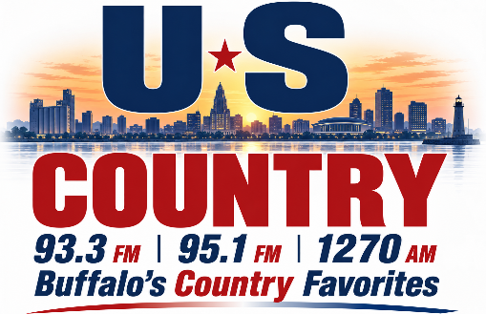
DIGITAL ADVERTISING
ONLINE AT
USCOUNTRY.COM
Last Updated 9/30/2026
Available Website Zone | Banner Size | Exclusive Monthly | Rotation Monthly
Footer Ad 1 | IAB Rectangle (180x150) | $50 | $25
Footer Ad 2 | IAB Rectangle (180x150) | $50 | $25
Footer Ad 3 | IAB Rectangle (180x150) | $50 | $25
Footer Ad 4 | IAB Rectangle (180x150) | $50 | $25
Footer Ad 5 | IAB Rectangle (180x150) | $50 | $25
Footer Leaderboard | IAB Leaderboard (728x90) | $100 | $50
Header Leaderboard | IAB Leaderboard (728x90) | $75 | $50
Homepage Leaderboard 1 | IAB Leaderboard (728x90) | $75 | $50
Homepage Leaderboard 2 | IAB Leaderboard (728x90) | $75 | $50
Mobile Ad Unit | Custom (320x50) | $75 | $50
Right Ad 1 | Custom (350x250) | $100 | $75
Right Ad 2 | Custom (350x250) | $100 | $75

2900 Genesee Street, Buffalo, NY 14225
Phone: 716-783-9120
USCOUNTRY.COM

